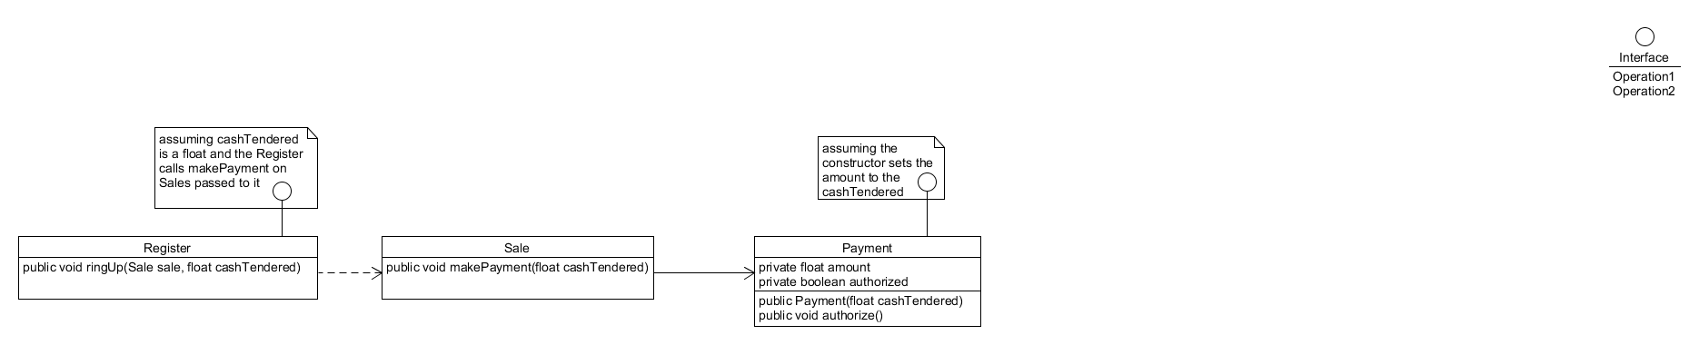1.

5.

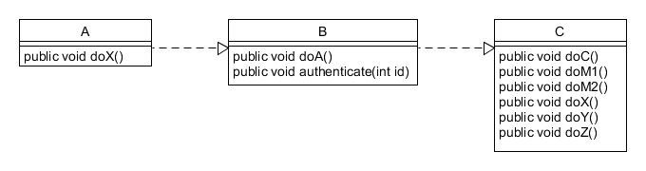

8.

Communication diagrams have a rather loose form similar to UML class diagrams. This aspect of communication diagrams can make them rather hard to follow as far as determining the order in which messages are passed. To make the diagram easier to follow, messages are labeled with numbers, correlating to the sequence in which they are passed to other objects. These types of diagrams are also difficult to write code/pseudocode for. They are more suited for giving a very general idea of how the system works. Despite their shortcomings with sequentially describing the steps in the system, communication diagrams are great at giving you a big picture view of the system. They focus more on the interactions between the objects rather than the time at which each object passes information from one to the next.

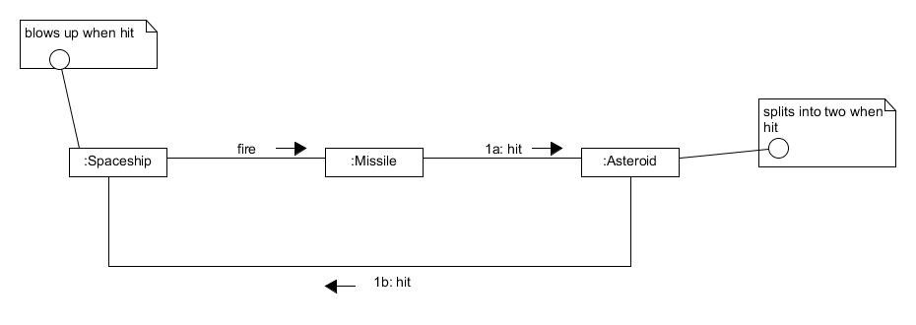

9.